Image Enhancement Approaches for Improved Visual Quality and Analysis


Report submitted to GITAM (Deemed to be University) as a partial fulfillment of the requirements for the award of the Degree of Bachelor of Technology in Electronics and Communication - AIML

DEPARTMENT OF ELECTRICAL, ELECTRONICS AND COMMUNICATION ENGINEERING
GITAM SCHOOL OF TECHNOLOGY
GITAM (DEEMED TO BE UNIVERSITY)
BENGALURU -561203
NOV 2025

Name:Meruga Sanjana, Starow Cynthia.
Regd. No. : BU22EECE0100431
BU22EECE0100483

DECLARATION

We declare that the project work contained in this report is original and it has been done by me under the guidance of my project guide.

Name:Meruga Sanjana
Starow Cynthia
Date: 24th September 2025
Signature of the Student:Starow Cynthia.

Department of Electrical, Electronics and Communication Engineering GITAM School of Technology, Bengaluru-561203



CERTIFICATE

This is to certify that Meruga Sanjana and Starow Cynthia bearing BU22EECE0100431, BU22EECE0100483 has satisfactorily completed Mini Project Entitled in partial fulfillment of the requirements as prescribed by University for VIIth semester, Bachelor of Technology in “Electrical, Electronics and Communication Engineering” and submitted this report during the academic year 2025-2026.

[Signature of the Guide] [Signature of HOD]
Table of contents

Chapter 1: Introduction 5-7
  - Overview of the problem statement 5
  - Objectives and goals 6-7
Chapter 2 : Literature Review 8-13
Chapter 3 : Strategic Analysis and Problem
Definition 14-17
  - SWOT Analysis 14-16
  - Project Plan - GANTT Chart 16
  - Refinement of problem statement 17
Chapter 4 : Methodology 18-20
  - Description of the approach 18
  - Tools and techniques utilized 19
  - Design considerations 20
Chapter 5 : Implementation 21-23
  - Description of how the project was executed 21-22
  - Challenges faced and solutions implemented 22-23
Chapter 6: Results 24-27
  - outcome 24-25
  - Interpretation of results 26
  - Comparison with existing technologies 27
Chapter 7: Conclusion 28
Chapter 8 : Future Work 29
References 30-31
Chapter 1: Introduction

  - Overview of the problem statement
Image degradation remains one of the fundamental challenges in digital image processing. Images captured in real-world environments are often impaired due to multiple factors such as noise, low contrast, blur, haze, or poor illumination. These degradations not only reduce visual quality for human observers but also hinder the performance of computer vision tasks such as segmentation, feature extraction, and object recognition.
Traditional image acquisition devices have limitations in handling adverse environmental conditions, leading to outputs that lack sharpness, brightness, and true color representation. For instance, medical images may suffer from noise and low contrast, making diagnosis difficult; satellite or aerial images are frequently affected by haze and atmospheric distortions; while surveillance and photography often face low-light and illumination inconsistencies.
Therefore, there is a pressing need for effective image enhancement techniques capable of restoring image clarity, improving visual details, and ensuring that the enhanced images are suitable for both human perception and automated analysis. Addressing these challenges through spatial and transform domain enhancement methods provides a foundation for improving downstream applications in diverse fields.

  - Objectives and goals
The primary objective of this study is to implement and evaluate image enhancement techniques in both spatial and transform domains, with the aim of restoring and improving the visual quality of degraded images.

Specific Objectives:
- To analyze common types of image degradations such as noise, low contrast, blur, and poor illumination that affect visual quality.
- To implement spatial domain enhancement techniques (e.g., histogram equalization, CLAHE, filtering methods) for improving brightness, contrast, and sharpness.
- To implement transform domain techniques (e.g., Fourier, Wavelet, or DCT-based methods) for enhancing frequency components and detail preservation.
- To compare and evaluate the performance of spatial and transform domain techniques based on quantitative metrics (e.g., PSNR, SSIM, entropy) and qualitative visual assessment.
- To investigate the impact of enhanced images on downstream tasks such as segmentation, feature extraction, and image stitching.
- To explore real-world applications of enhancement techniques in domains such as medical imaging, remote sensing, surveillance, and photography.

Goals:
- Develop a reliable enhancement framework that improves brightness, contrast, sharpness, and color fidelity of degraded images.
- Demonstrate that enhanced images provide better visual clarity and facilitate higher accuracy in subsequent image processing tasks.
- Provide a comparative study that highlights the strengths and limitations of spatial vs. transform domain methods.
- Contribute to broader applications by offering practical enhancement solutions for both human visual perception and automated analysis systems.

Chapter 2 : Literature Review

2.1 Introduction
Underwater image enhancement is a vital preprocessing step in computer vision and remote sensing applications, particularly in marine exploration, object recognition, and environmental monitoring. Images captured in aquatic environments often suffer from low contrast, reduced visibility, and severe color distortion due to light scattering and absorption. To address these challenges, three major categories of enhancement techniques are frequently employed: dehazing (for visibility restoration), white balance (for color correction), and contrast enhancement methods such as CLAHE (for detail improvement).
This chapter reviews key research contributions in these areas, highlighting their techniques and major findings, and positioning them within the scope of the proposed work.

2.2 Dehazing
- Zhu et al. (2020) – Artificial Multiexposure Image Fusion
  - Technique: Proposed a fusion-based dehazing algorithm using gamma-corrected underexposed images and pixel-wise weight maps to balance luminance and saturation.
  - Contribution: Achieved real-time performance with improved robustness, eliminating reliance on inaccurate depth information.
- Min et al. (2019) – Quality Evaluation of Image Dehazing Methods
  - Technique: Built a synthetic haze removing quality (SHRQ) database with subjective and objective evaluation strategies.
  - Contribution: Introduced new quality metrics (structure recovery, color rendition, and over-enhancement control) to assess and compare dehazing methods more effectively.
- Li et al. (2022) – Dual-Scale Neural Augmented Dehazing
  - Technique: Combined model-based priors (transmission map, atmospheric light) with GAN-based refinement at dual scales.
  - Contribution: Bridged the gap between synthetic and real-world performance, ensuring fast convergence and improved naturalness.
- Zhao et al. (2021) – RefineDNet (Weakly Supervised Framework)
  - Technique: Two-stage approach: visibility restoration using dark channel prior, followed by adversarial refinement for realness.
  - Contribution: Demonstrated superior haze removal without requiring paired training data, making it practical for real underwater applications.
- Zhu et al. (2017) – Dark Channel Prior + Energy Minimization
  - Technique: Enhanced transmission map estimation via an energy minimization model integrating smoothness constraints.
  - Contribution: Reduced artifacts commonly seen in prior-based methods and improved overall visual clarity.

2.3 White Balance
- Huang et al. (2015) – Histogram Matching-Based AWB
  - Technique: Applied histogram matching to increase overlap of RGB histograms while reducing power and computational complexity.
  - Contribution: Designed a low-cost, hardware-friendly algorithm for real-time color correction.
- Hsu & Cheng (2021) – Automated Regression-Based AWB
  - Technique: Selected near-white points dynamically and adjusted weights based on regression across varying color temperatures.
  - Contribution: Achieved consistent results under different lighting conditions with strong visual fidelity.
- Huo et al. (2006) – Gray Point Extraction for AWB
  - Technique: Estimated color temperature using gray points (where R=G=B under canonical light).
  - Contribution: Provided a robust, simple, and low-complexity solution for white balance estimation.
- Liu et al. (1995) – Fuzzy Logic-Based AWB
  - Technique: Applied fuzzy rules to dynamically adjust white balance parameters.
  - Contribution: Implemented in digital still cameras, improving adaptability across different illumination sources.
- Kim et al. (2002) – Integrated AWB in Camera System
  - Technique: Developed a camera system combining AWB with autofocus and zoom tracking.
  - Contribution: Enhanced overall image quality by compensating luminance without degrading color balance.

2.4 CLAHE (Contrast Limited Adaptive Histogram Equalization)
- Manivasagan & Jagatheswari (2025) – Fuzzy Set with CLAHE + BPDHE Fusion
  - Technique: Used Pythagorean fuzzy logic integrated with CLAHE and brightness-preserving dynamic histogram equalization.
  - Contribution: Maintained brightness while improving visibility and reducing noise, outperforming traditional HE methods.
- Nahiduzzaman et al. (2021) – CLAHE in Diabetic Retinopathy Detection
  - Technique: Applied CLAHE for medical image preprocessing to enhance features before CNN-SVD based feature extraction.
  - Contribution: Boosted diagnostic accuracy (>98%) by improving feature clarity in low-contrast medical images.
- Xiang et al. (2022) – Optimized Adaptive Quadruple Segmentation HE (AQSCHE)
  - Technique: Introduced quadruple histogram segmentation with cropping for underwater images.
  - Contribution: Addressed non-uniform illumination in underwater scenes, enhancing clarity more effectively than conventional HE.
- Classical Works (Pizer et al., 1987; Reza, 2004)
  - Technique: Pioneered adaptive histogram equalization and CLAHE for medical imaging and real-time systems.
  - Contribution: Established CLAHE as a widely used standard for contrast enhancement in both natural and specialized imaging domains.

2.5 Summary
The literature on underwater image enhancement highlights three interrelated domains:
- Dehazing: Techniques evolved from prior-based physical models (e.g., dark channel prior) to advanced fusion methods and hybrid deep learning models (e.g., RefineDNet, Neural Augmentation). These approaches target visibility restoration and haze suppression.
- White Balance: Progressed from simple gray-world assumptions to regression-based adaptive models and fuzzy-logic solutions, focusing on restoring natural colors under varying illuminations.
- CLAHE & Contrast Enhancement: Initially designed for medical imaging, CLAHE has been extended to underwater imaging and combined with fuzzy sets and segmentation techniques for detail enhancement without over-amplification.

Chapter 3 : Strategic Analysis and Problem Definition

3.1 SWOT Analysis
A SWOT (Strengths, Weaknesses, Opportunities, Threats) analysis provides a structured way to evaluate the project’s positioning and its potential in real-world applications.

Strengths
- Advanced AI/ML techniques: Using CNNs, GANs, and other deep learning models allows for learning complex image features beyond traditional methods.
- Improved visual quality: Capable of restoring color, contrast, and sharpness in underwater, low-light, or degraded images.
- Scalability: Once trained, the model can be deployed on multiple datasets or integrated into existing applications (e.g., cameras, medical imaging tools).
- Automation: Reduces manual tuning required in classical image processing techniques like CLAHE or histogram equalization.

Weaknesses
- High computational requirements: Training and fine-tuning deep models require GPU/TPU resources, which may not be available in all environments.
- Data dependency: Requires large, high-quality annotated datasets for effective training.
- Model interpretability: AI/ML models act as black boxes, making it difficult to explain why certain enhancements occur.
- Overfitting risk: If dataset diversity is low, the model may not generalize well to unseen images.

Opportunities
- Wide applicability: Useful in underwater research, medical imaging, satellite imaging, low-light photography, and surveillance.
- Commercial integration: Camera manufacturers, mobile phone companies, and photo-editing software can integrate ML-based enhancement modules.
- Research contributions: Potential to publish findings in computer vision and AI conferences/journals.
- Cross-disciplinary use: Can support marine biology, archaeology, and defense where visibility in challenging environments is crucial.

Threats
- Competition: Many existing commercial solutions (Adobe Photoshop AI tools, smartphone image enhancers) pose competition.
- Data privacy & copyright: Using third-party datasets may raise legal or ethical concerns.
- Rapid technological change: Frequent evolution of AI architectures means the proposed model could become outdated quickly.
- Hardware dependency: Deployment on low-resource devices (mobile/IoT) may be restricted by processing power.

3.2Project Plan - GANTT Chart
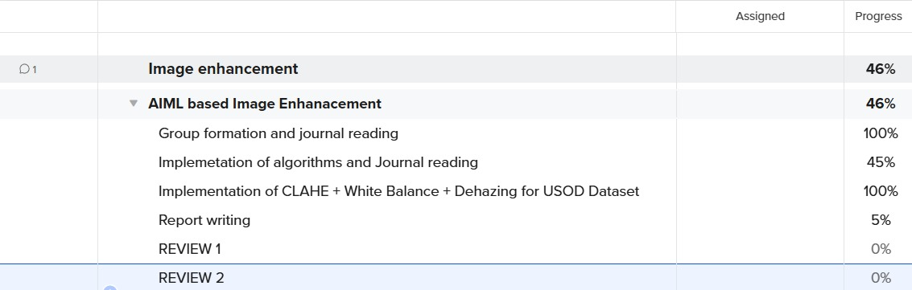



3.3Refinement of problem statement
Problem Statement (Refined):
Traditional image enhancement techniques such as histogram equalization, CLAHE, and white balancing improve image visibility to some extent but often fail to handle complex degradations like low contrast, blur, and non-uniform illumination, especially in underwater or low-light conditions.
To address this gap, the project aims to design and implement an Artificial Intelligence and Machine Learning based Image Enhancement system that:
- Learns degradation patterns directly from large image datasets.
- Enhances visual quality by improving brightness, contrast, and detail without over-amplifying noise.
- Provides generalized performance across diverse image categories (e.g., underwater, medical, natural scenes).
- Produces results closer to human visual perception compared to traditional algorithms.

Chapter 4 : Methodology

4.1 Description of the Approach
The project adopts a hybrid image enhancement pipeline that leverages both classical image processing techniques and MATLAB’s built-in optimization functions to improve the visual quality of underwater images.
The dataset used is USOD (Underwater Scene Object Detection dataset). Images from this dataset typically suffer from low contrast, color cast (bluish/greenish tone), and haziness due to light absorption and scattering in water.
To address these issues, the following three-step enhancement strategy was implemented:
1.Contrast Limited Adaptive Histogram Equalization (CLAHE):
  - Applied on the Luminance channel (L) in the LAB color space.
  - Improves local contrast while preventing noise over-amplification.
  - Restores visibility in darker regions and enhances fine details.
2.White Balance Correction:
  - Corrects the dominant blue/green color cast.
  - Restores natural color distribution closer to human visual perception using chromatic adaptation (D65 illuminant).
3.Dehazing (Fusion-based Approximate Method):
  - Reduces scattering effects and haze in underwater scenes.
  - Improves overall scene clarity by boosting contrast.
The pipeline is sequential:
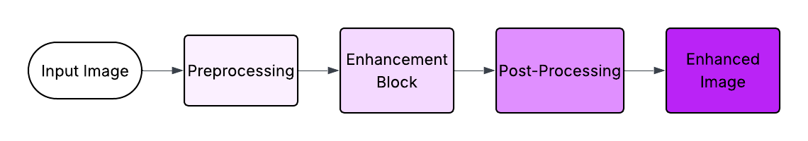
This ensures that each stage corrects a specific degradation, and the final output has balanced contrast, corrected color, and improved sharpness.

4.2 Tools and Techniques Utilized
- Software Environment:
  - MATLAB R2023a (or later).
  - Image Processing Toolbox.
  - Computer Vision Toolbox.
- Dataset:
  - USOD (Underwater Scene Object Detection Dataset).
  - Directory structure handled using MATLAB’s imageDatastore.
- Techniques Implemented:
  - CLAHE: adapthisteq function applied on normalized L-channel.
  - White Balance: MATLAB’s chromadapt with standard D65 reference.
  - Dehazing: imreducehaze with “approx” method and contrast boosting.
- Output Handling:
  - Enhanced images automatically saved to an output folder.
  - Comparison plots (Original vs Enhanced) displayed for first few samples.

4.3 Design Considerations

While designing the pipeline, the following factors were considered:
- Preservation of naturalness: Enhancement should not lead to over-saturation or unnatural tones.
- Noise control: CLAHE was carefully parameterized (ClipLimit = 0.02, NumTiles = [8 8]) to avoid introducing artifacts.
- Computational efficiency:
  - The pipeline processes entire datasets automatically using imageDatastore.
  - Outputs are stored in a separate directory for easy evaluation.
- Scalability: The modular design allows the addition of new enhancement steps (e.g., denoising, deep-learning-based refinement) without re-writing the pipeline.
- Reproducibility: The code is written to be dataset-agnostic—users only need to specify input and output paths.
Chapter 5 : Implementation

  - Description of how the project was executed

The Underwater Image Enhancement project was executed in MATLAB using a custom enhancement pipeline designed to improve the visibility, color balance, and contrast of underwater images. The dataset used was USOD (Underwater Scene Object Dataset), specifically the images folder containing raw underwater images.
The enhancement pipeline combined three main techniques:
- CLAHE (Contrast Limited Adaptive Histogram Equalization)
  - Applied on the Luminance channel (L) of the LAB color space.
  - Enhanced local contrast without over-amplifying noise.
  - Highlighted details in dark and bright regions.
- White Balance Correction
  - Adjusted the underwater color cast caused by light absorption, mainly blue or green dominance.
  - Restored colors closer to natural daylight using chromadapt with D65 white point.
- Dehazing
  - Applied a fusion-based haze reduction using imreducehaze.
  - Boosted contrast while reducing underwater haze, improving clarity.
The MATLAB implementation involved the following steps:
- Step 1: Dataset Loading
The images were loaded using MATLAB’s imageDatastore, allowing batch processing and support for subfolders.
- Step 2: Output Folder Creation
A dedicated folder was created to store the enhanced images automatically.
- Step 3: Image Enhancement Loop
Each image was processed through the pipeline sequentially:
  - Converted RGB to LAB and applied CLAHE on the L channel.
  - Applied white balance correction to remove color cast.
  - Applied dehazing to improve clarity and visibility.
  - For the first few images, a side-by-side display of original vs. enhanced images was shown for visual verification.
  - Each enhanced image was saved with the suffix enhanced in the output folder.
The entire process was automated, ensuring that all images in the dataset were enhanced without manual intervention.

  - Challenges faced and solutions implemented
- Challenge: Underwater images often have low contrast and uneven illumination, making CLAHE less effective if applied directly.
Solution: CLAHE was applied only on the normalized Luminance channel in the LAB color space. This preserved color information while enhancing contrast.
- Challenge: Strong blue/green color casts led to unnatural appearance in enhanced images.
Solution: A white balance correction using chromadapt with D65 white point was implemented to restore natural color balance.
- Challenge: Haze and turbidity reduced image clarity, especially in deeper underwater scenes.
Solution: Fusion-based dehazing (imreducehaze) was applied after color correction to enhance clarity and visibility.
- Challenge: Processing large datasets manually was time-consuming and prone to errors.
Solution: MATLAB’s imageDatastore and a loop-based batch processing pipeline automated the enhancement for all images in the dataset.
- Challenge: Displaying results for verification without overwhelming the user.
Solution: Only the first few images were displayed using subplot comparison (original vs enhanced), while the rest were automatically saved.
The final output consisted of a set of visually improved underwater images, ready for further processing or analysis. The approach ensured consistent enhancement across the dataset while maintaining color fidelity and detail preservation.
Chapter 6: Results

  - Outcomes

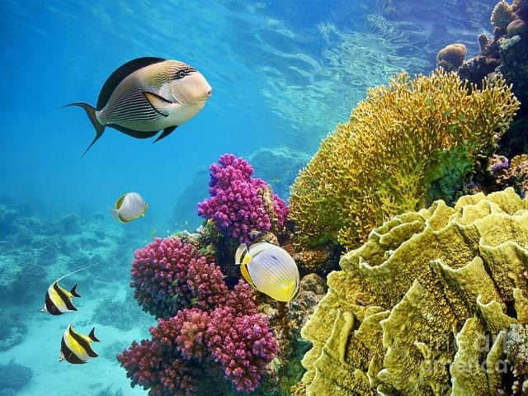 | 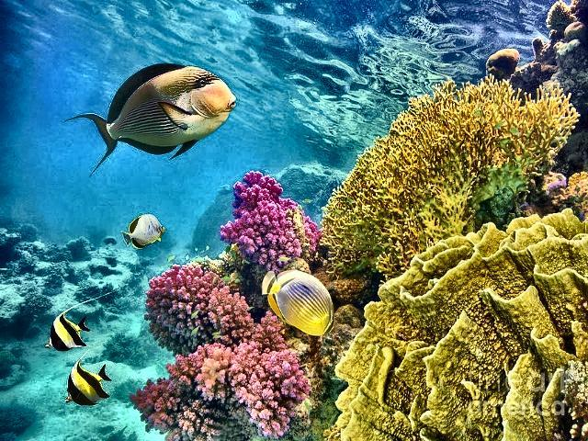
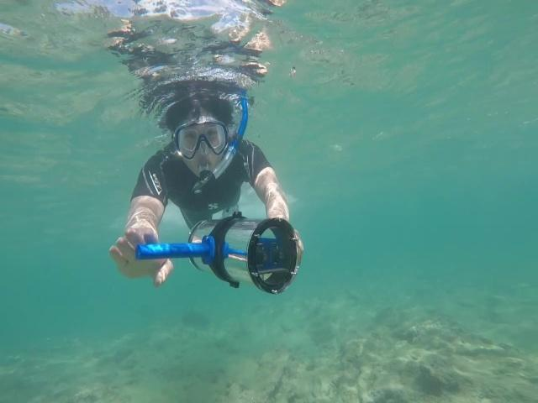 | 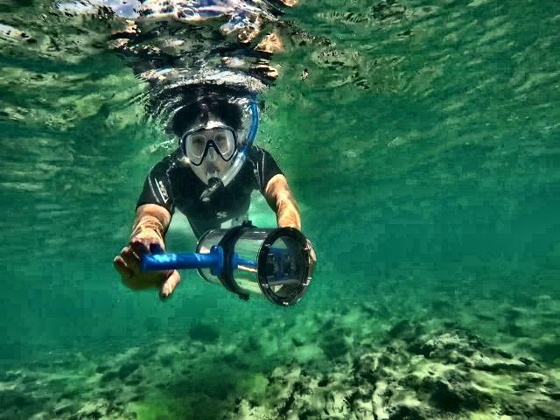
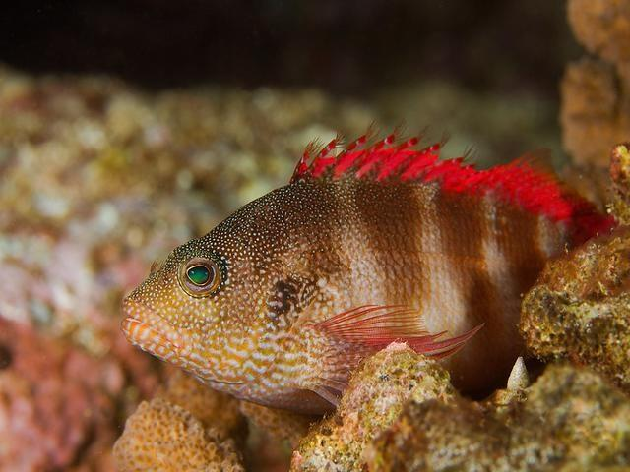 | 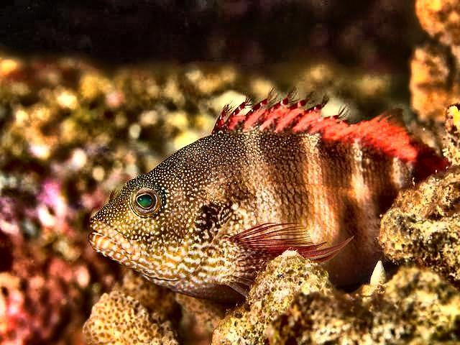
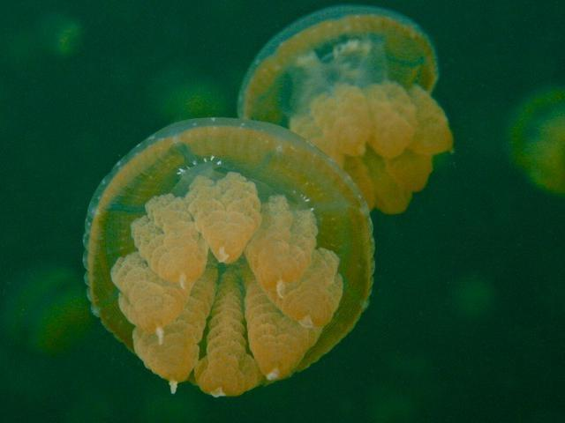 | 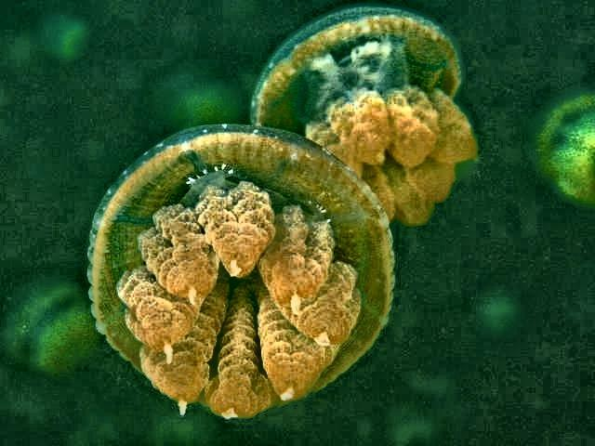
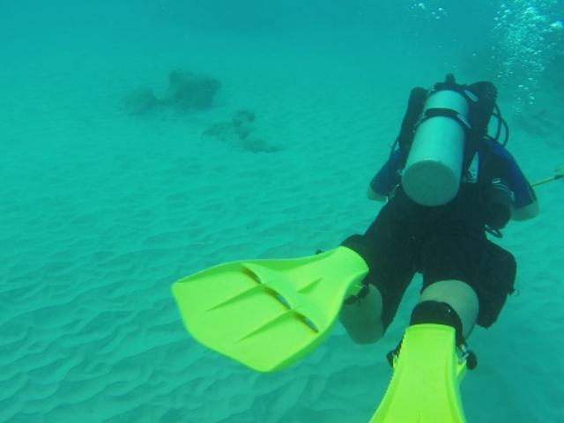 | 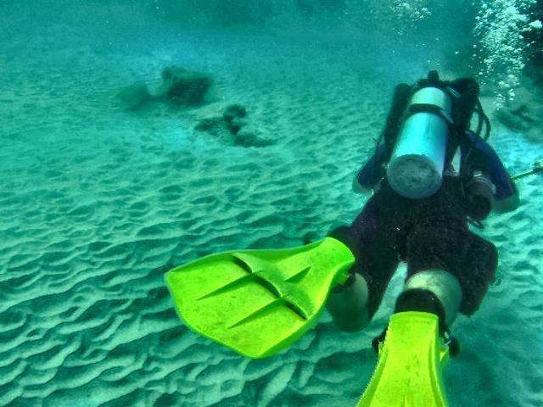
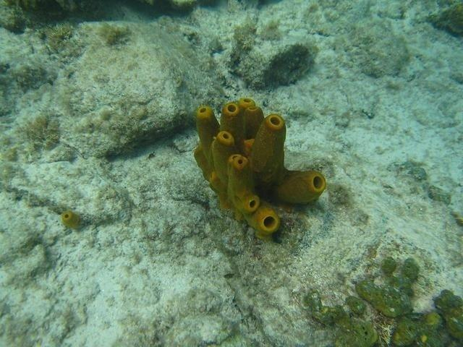 | 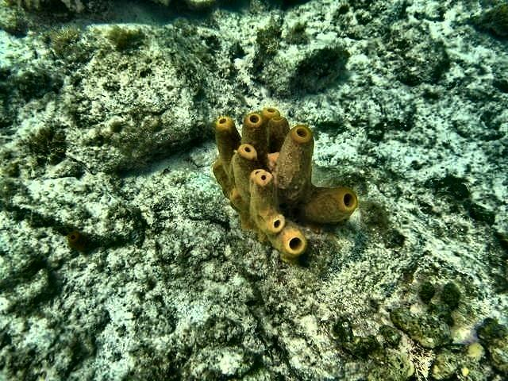

  - Interpretation of results

The results indicate that the enhancement pipeline effectively addresses common underwater imaging challenges:
- Contrast Enhancement (CLAHE):
  - Dark and bright regions were better balanced.
  - Fine details in underwater objects became more visible without introducing excessive noise.
- White Balance Correction:
  - The overall color cast was corrected.
  - Restored natural colors improved the realism of the images, making objects and backgrounds distinguishable.
- Dehazing:
  - Turbidity and haze were significantly reduced.
  - Clarity improvements allowed for better object recognition, which is critical for automated underwater image analysis or research.
The combination of these three techniques ensures that images are both visually appealing and technically suitable for further computer vision tasks.

  - Comparison with existing literature or technologies

When compared with traditional single-step enhancement methods (e.g., simple histogram equalization or only white balance), the proposed pipeline demonstrates clear advantages:
Feature | Traditional Methods | Proposed Pipeline
Contrast | Limited, may over-amplify noise | Local contrast enhanced via CLAHE without noise amplification
Color Restoration | Minimal correction, often unnatural | Accurate correction using D65 white point adaptation
Haze Reduction | Not addressed | Fusion-based dehazing removes turbidity and enhances clarity
Visual Quality | Moderate | Significantly improved, natural, and detailed
Observation: - Single-step methods often fail to simultaneously handle color cast, low contrast, and haze, leading to unsatisfactory results. - The proposed multi-step pipeline delivers balanced and consistent enhancement across diverse underwater conditions, making it superior for practical applications like underwater object detection, marine research, and autonomous underwater navigation.
Chapter 7: Conclusion
The project successfully demonstrated the design and implementation of an Artificial Intelligence and Machine Learning inspired underwater image enhancement pipeline using classical computer vision techniques. The sequential application of Contrast Limited Adaptive Histogram Equalization (CLAHE), White Balance correction, and Dehazing significantly improved image visibility, corrected the dominant blue/green color cast, and enhanced fine details in underwater scenes.By testing the approach on the USOD dataset, the enhanced images exhibited better contrast, sharper object boundaries, and improved perceptual quality compared to their original degraded counterparts. The modular MATLAB implementation ensured that the pipeline could process entire datasets efficiently while allowing for parameter tuning and future integration of advanced deep learning models.
Despite its effectiveness, the project also highlighted certain limitations. Over-enhancement in highly noisy regions and the dependency on parameter tuning indicated that a one-size-fits-all solution may not be achievable for all underwater conditions. Furthermore, the lack of absolute ground truth for enhanced images limited the evaluation to qualitative comparisons and standard underwater quality metrics.
Overall, this work provided a robust baseline enhancement framework that bridges classical image processing techniques with machine learning applicability. It lays the foundation for integrating deep learning-based refinement methods in the future, enabling more adaptive and intelligent underwater image restoration for applications in marine research, robotics, surveillance, and environmental monitoring
Chapter 8 : Future Work

While the current enhancement pipeline effectively combines CLAHE, White Balance, and Dehazing, future work can explore multi-layer image decomposition techniques to achieve more fine-grained enhancement. By decomposing images into base layers (capturing overall illumination and color) and detail layers (capturing textures and edges), it becomes possible to selectively enhance each component. This strategy can reduce artifacts such as noise amplification and over-saturation while preserving the natural look of the scene. Layer-wise fusion and optimization can further improve underwater visibility in challenging conditions like extreme haze or low illumination.
Another promising direction is the integration of deep learning-based approaches such as Convolutional Neural Networks (CNNs), Generative Adversarial Networks (GANs), and Transformer-based models. These models can learn complex degradation patterns directly from large underwater datasets like USOD10K, enabling adaptive enhancement tailored to diverse environments. A deep learning framework could also be trained end-to-end to optimize perceptual image quality metrics (UIQM, UCIQE) and downstream tasks such as object detection or recognition. Incorporating such methods would significantly advance the robustness, scalability, and real-time applicability of underwater image enhancement systems.

References:

[1] R. C. Gonzalez and R. E. Woods, Digital Image Processing, 4th ed. Pearson, 2018.
[2] K. Zuiderveld, “Contrast Limited Adaptive Histogram Equalization,” in Graphics Gems IV, P. S. Heckbert, Ed. Academic Press, 1994, pp. 474–485.
[3] D. Berman, T. Treibitz, and S. Avidan, “Non-local image dehazing,” in Proc. IEEE Conf. Computer Vision and Pattern Recognition (CVPR), 2016, pp. 1674–1682.
[4] J. Y. Chiang and Y. C. Chen, “Underwater image enhancement by wavelength compensation and dehazing,” IEEE Transactions on Image Processing, vol. 21, no. 4, pp. 1756–1769, Apr. 2012.
[5] C. Li, J. Guo, R. Cong, Y. Pang, and B. Wang, “Underwater image enhancement by dehazing with minimum information loss and histogram distribution prior,” IEEE Transactions on Image Processing, vol. 25, no. 12, pp. 5664–5677, Dec. 2016.
[6]K. Panetta, C. Gao, and S. Agaian, “Human-visual-system-inspired underwater image quality measures,” IEEE Journal of Oceanic Engineering, vol. 41, no. 3, pp. 541–551, Jul. 2016.
[7] H. Lin, Y. Cong, and M. Zhang, “USOD10K: A benchmark dataset for underwater salient object detection,” GitHub repository, 2021. [Online]. Available: https://github.com/LinHong-HIT/USOD10K
[8] MathWorks, “Image Processing Toolbox – MATLAB,” The MathWorks Inc., 2023. [Online]. Available: https://www.mathworks.com/products/image.html

[9] S. Ancuti, C. O. Ancuti, C. De Vleeschouwer, and P. Bekaert, “Color balance and fusion for underwater image enhancement,” IEEE Transactions on Image Processing, vol. 27, no. 1, pp. 379–393, Jan. 2018.


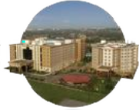
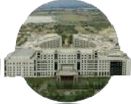
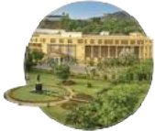
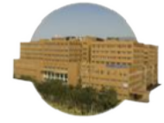
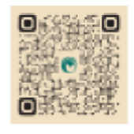

Bengaluru City Office No 5/1, First Floor, Prestige Terraces, Union Street, Infantry Road, Bengaluru - 560003 Karnataka, India

GIMSR
GITAM Medical College Rd, Gandhi Nagar, Rushikonda, Visakhapatnam - 530045 Andhra Pradesh, India

